FOR COLOUR SCHEME USE WebAim website. Link: <”Link”>

Design documentation for the project

**Topic**: Analysing the problem and

designing a solution

**Evidence**: Proposal of the designed solution; A set of design documents

**Time**: 20 hours

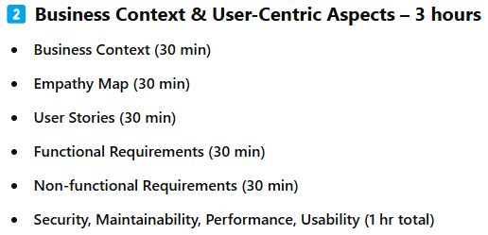

**Task 1 A (ii)**

**Business Context**

**Main Tip**: For this task, you have to explain why you have been ‘hired’ to help the client. Explain;

* what the client does
* why the client wants your services (leaning towards their main goal, i.e. engaging new clients)
* what the client wants you to make (what they have literally asked you to make)

Most of this task is already done for you, since all of the information you need is already there, you just need to put it together neatly.

**Examples**: Our client, Riget Zoo Adventures (RZA), is a well-established business that is interested in digitalisation in

order to keep existing customers satisfied as well as engaging new clients, Currently RZA offers a safari-  
style wildlife zoo, an on-site hotel and educational visits. A client is looking for a digital solution that

would information about attractions and facilities, materials to support educational visits and allow users  
to book tickets and stays in the hotel.  
I am proposing to develop an interactive website that would include all the features that the client  
requires and some more. In the following passages I will be explaining and justifying my proposal.

—---------------

Riget Zoo Adventures is a wildlife park and tourist attraction aiming to provide an educational and engaging experience for visitors, focusing on animal conservation and sustainable tourism. The zoo attracts many local and international visitors annually and is looking to enhance their visitor experience, improve operational efficiency, and increase customer engagement using digital technologies.

**Sources to use**:

**Examiner reports**:

**SWOT Analysis**

**Main tip:** SWOT stands for Strengths, Weaknesses, Opportunities, and Threats.

What you need to do is list all of the above in the format you prefer, a table is easier to visualize.

* Strengths - think of personal strengths within the company, i.e. their team or skills that they are proficient with.
* Weaknesses - personal weakness within the company, i.e. limited budget or outdated equipment.
* Opportunities - these are similar to strengths but from the outside, things that the company *usually* can’t control, i.e. Demand for digital technologies.
* Threats - similar to weaknesses, but from the outside, i.e. Increased competition from similar companies.

**Examples:** 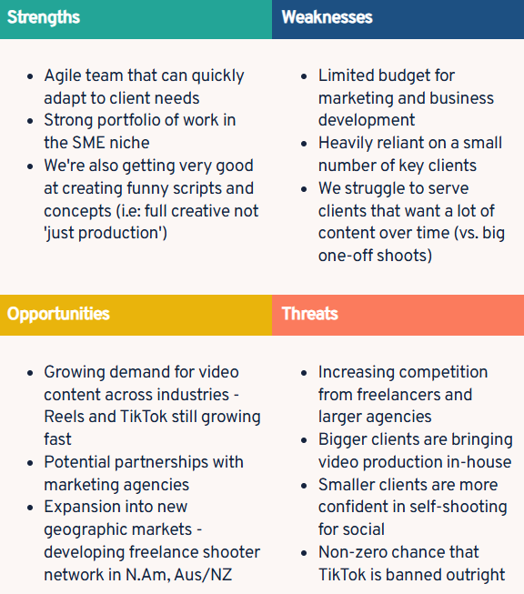

1. Strengths
   1. **Engaging Content**: The website offers a variety of interactive and educational content, such as animal facts, videos, virtual tours, and conservation information.
   2. **User-Friendly Design**: The website is easy to navigate, with a clear layout that allows visitors to quickly find information about ticketing, exhibits, events, and more.
   3. **Online Ticket Sales**: Convenient online ticketing system that helps reduce long lines and offers special discounts or promotions.
   4. **Community Engagement**: Provides opportunities for users to donate, adopt animals, and participate in community events, fostering a sense of involvement and support.
2. Weaknesses
   1. **Limited Accessibility Features**: The website may not fully cater to people with disabilities (e.g., lack of screen reader compatibility or language options).
   2. **Lack of Multi-Language Support**: The site may only be available in one language, limiting accessibility for international audiences.
   3. **Slow Load Times**: Some pages or high-quality media may take longer to load, which could frustrate users and drive them away.
   4. **Inadequate Search Functionality**: The search bar may not always yield the most relevant results, making it harder for users to find specific information.
3. Opportunities
   1. **Virtual Animal Encounters**: Expand virtual zoo experiences like live-streamed animal feeds, behind-the-scenes tours, or interactive Q&A with zookeepers, which could attract more global visitors.
   2. **Increased Focus on Conservation**: Highlighting the zoo's conservation efforts through blog posts, videos, and donation opportunities could resonate with eco-conscious visitors and increase support.
   3. **Partnerships with Schools**: Creating educational resources and programs for schools could lead to increased traffic, both from teachers and students.
   4. **E-commerce Opportunities**: Adding an online store with zoo-themed merchandise or even tickets and memberships could create an additional revenue stream.
   5. **Enhanced Social Media Integration**: Integrating live social media feeds or user-generated content (e.g., visitors' photos and reviews) on the website could increase engagement and drive traffic.
4. Threats
   1. **Competition from Other Attractions**: Other family-friendly attractions (museums, aquariums, theme parks) may have better marketing or offers, drawing attention away from the zoo.
   2. **Economic Factors**: Economic downturns or changes in disposable income may reduce overall visitorship to the zoo, affecting both online and on-site engagement.
   3. **Technology Issues**: Technical glitches or outdated infrastructure could result in downtime, leading to poor user experience or loss of potential ticket sales.
   4. **Environmental or Animal Welfare Concerns**: Negative press regarding animal welfare or environmental impact could harm the zoo's reputation and online image.

**Security Risks**: Data breaches or security vulnerabilities, especially in online transactions, could damage user trust and the zoo’s credibility.

**Sources to use:**

**Examiners report:**

**Stakeholders**

**Main tip:** Explain the people that hold a stake in your company, public, managers, staff, etc.

You need 2 sections, one for explaining your general stakeholders and one for explaining your primary stakeholders.

Explain how it will affect your solution, if it will at all, and you’ll be good to go.

Just write a list of stakeholders and then explain how and why they have a stake in the business, Don’t worry if it doesn’t look like a lot, it’s a very small task.

**Examples:** Direct Stakeholders + Empathy Map

Customers (car buyers and sellers)

Needs:

Easy navigation, detailed vehicle information, secure payment process,

transparent pricing

User Story:

"As a first-time car buyer, I want to easily browse and compare different car

models on CarMax's website so that I can make an informed decision about my

purchase."

Empathy Map:

Think & Feel: Excited about purchasing a new car but anxious about making

the right choice and finding good value

See: Car listings, prices, specifications, competitor websites

Say & Do: Research vehicles online, ask friends for recommendations, visit

dealerships

Hear: Advice from friends, marketing messages, sales pitches

Pain Points: Uncertainty about vehicle history, negotiating prices, lack of

transparency

Employees (sales representatives, mechanics, customer service)

Needs: Access to inventory data, customer management tools, communication

Systems

User Story: "As a sales representative, I want to quickly access vehicle and

customer information so I can provide personalized assistance and close sales

efficiently."

Empathy Map:

Think & Feel: Motivated by sales targets, wants to provide good customer

service

See: Customer inquiries, inventory updates, sales performance metrics

Say & Do: Answer customer questions, showcase vehicles, process

transactions

Hear: Customer concerns, management directions, performance feedback

Pain Points: System downtime, incomplete information, difficult customers

Shareholders and investors

Needs: Profitability, growth, competitive advantage in the market

User Story: "As an investor, I want to be provided with up to date information

about the company through a newslertter."

Empathy Map:

Think & Feel: Concerned about ROI, market position, and long-term growth

See: Financial reports, market trends, competitor performance

Say & Do: Analyze financial data, ask about strategic initiatives, evaluate

business performance

Hear: Quarterly reports, industry news, management presentations

Pain Points: Market volatility, insufficient transparency, slow adaptation to

market trends

Indirect Stakeholders

Local communities where CarMax operates

Needs: Economic benefits, employment opportunities, responsible corporate

citizenship

User Story: "As a community member, I want CarMax to provide local

employment opportunities and contribute to community initiatives."

Empathy Map:

Think & Feel: Concerned about local economy and environmental impact

See: Job postings, community involvement, business expansion

Say & Do: Apply for jobs, participate in sponsored events, provide

community feedback

Hear: News about company growth, charitable activities, environmental

practices

Pain Points: Traffic congestion, environmental concerns, unfilled promises

**Sources to use:**

**Examiners report:**

**User Stories**

**Main tip:** User stories are made to explain what the user wants and why they want it, this also allows you to plan what your system needs.

You should do one for a;

* First time customer
* Student
* Parent
* Loyal customer

(You can also do ones for different users, i.e. teacher)

You need to talk about 3 things;

* What the user wants
* Why the user wants it
* The acceptance criteria

**Examples:**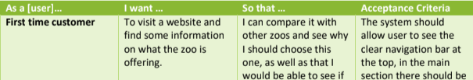

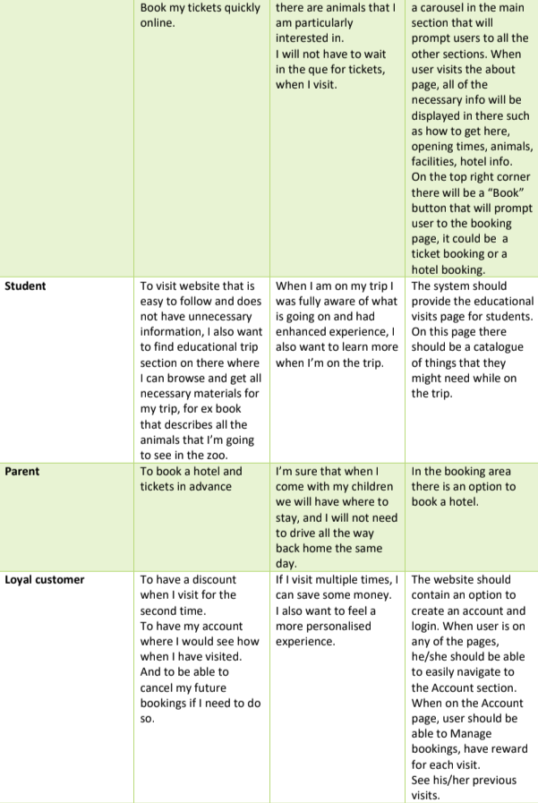

**Sources to use:**

**Examiners report:**

**User Acceptance Criteria**

**Main tip:** You can combine this with the User Stories.

This is to specify what the user thinks is acceptable of the website. For example;

* The website is quick to load
* It should have appropriate images
* It should be easy to navigate
* The website should look nice

Of course, if you want to do it separately, go ahead, though it is easier to integrate it within the user stories.

**Examples:**

**Sources to use:**

**Examiners report:**

**UML Case Diagrams**

**Main tip:** This is for visualizing how different users interact with the system. UML diagrams can help outline user interactions and plan features.

You must always put everything in a big box, a.k.a. the System Boundary. Every ‘UseCase’ is in the ovals, so everything the user is interacting with and can do. The stick men are ‘Actors’ which is what you use to represent the end points of everything, the user, the payment service, authentication service, paypal, etc.

The ‘<<Include>>’ means that the use case, that the arrow is pointing to, *includes* the functionality of another use case, the one the arrow is coming from.

The ‘<<Extend>>’ means that the use case, that the arrow is pointing to, is an extension of functionality of another use case, the one the arrow is coming from.

**Examples:**

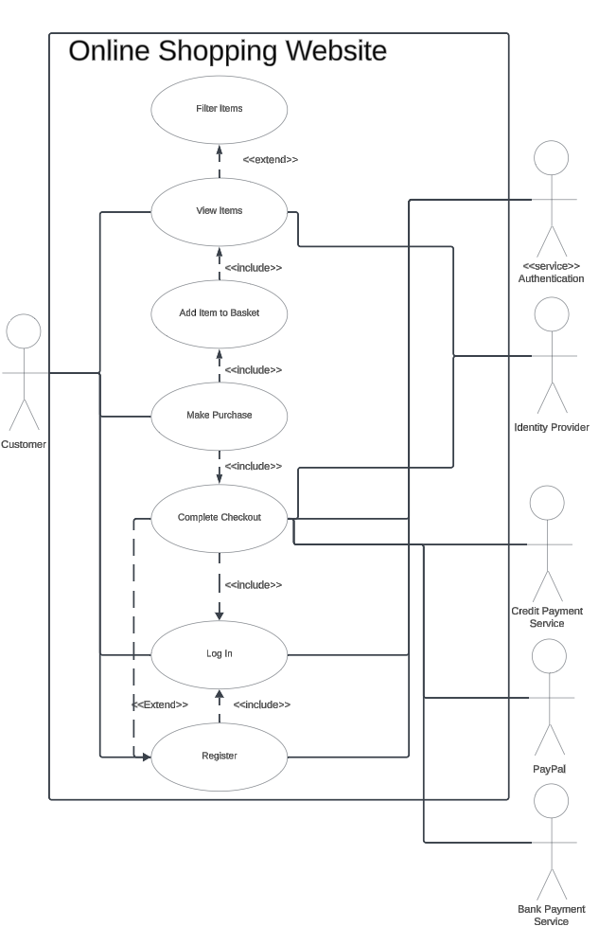

**Sources to use:** *Geeks for Geeks* **-** [**https://www.geeksforgeeks.org/use-case-diagram/**](https://www.geeksforgeeks.org/use-case-diagram/)

**Examiners report:**

**Empathy Map**

**Main tip:** An empathy map is to show what your users will be saying, thinking, doing, and feeling. Usually, you pick a stakeholder to do it about. However, you can do it generally for everyone.

The easiest way to do one is to try and think as one of the users and write down what you are;

* Saying - What have we heard them say? What can we imagine them saying? What’s their attitude?
* Thinking - What really matters to them? What do they want? What are they having trouble with?
* Doing - What can we imagine them doing? What are their behaviour?
* Feeling - What are their frustrations and anxieties? What are their needs?

**Examples:**

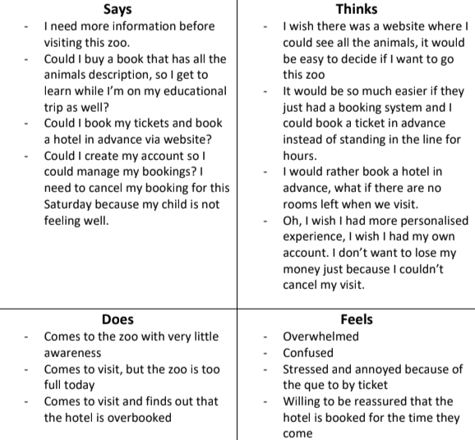

**Sources to use:**

**Examiners report:**

**Functional Requirements and Non-Functional Requirements**

**Main tip:** If you *really* need to know how to do them

Functional requirements are what the website *needs* to do what it its made for, the bare minimum that lets it do its job

Non-Functional requirements are any extras for the website, anything that *adds* to its original function. Usually for user experience and quality of life.

**Examples:**

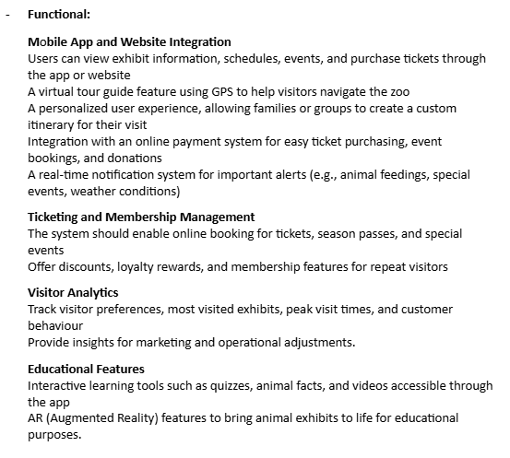

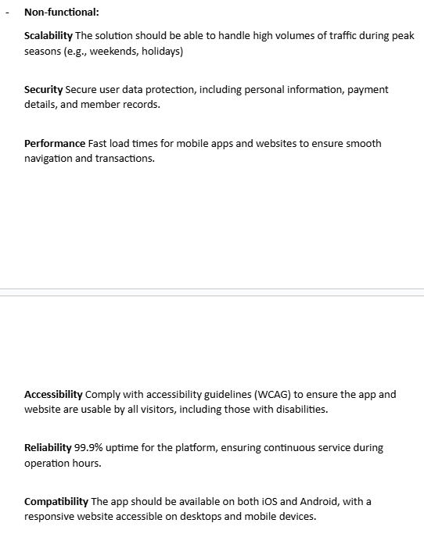

**Sources to use:**

*Geeks for Geeks*-[**https://www.geeksforgeeks.org/functional-vs-non-functional-requirements/**](https://www.geeksforgeeks.org/functional-vs-non-functional-requirements/)

**Examiners report:**

**Decomposition of problem**

**Main tip:** This to decompose the functional and non-functional requirements that you have done previously.

You can decompose the problems how you’d like to, some ideas;

* Table - has the columns for the feature, priority, and justification.
* Flow charts - very basic flowcharts for each problem, giving steps for the user and server.
* Within the requirements - Flow charts, tables, etc. within the functional and non-functional requirements.

You should also decompose the site pages with what they contain.

**Examples:**

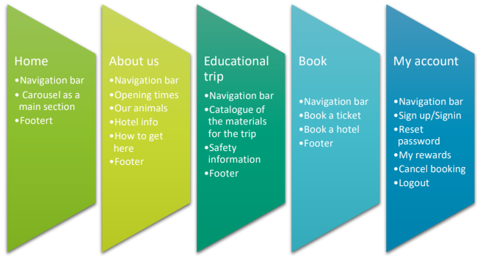

**Sources to use:**

**Examiners report:**

**TechStack of Solution**

**Main tip:** Just list the things you will use, and use in theory.

You need to specify what you are using for the front end, back end, and any APIs. You will also need to explain what each of them are and what it does.

If you are normal, you will be using HTML, CSS for front end (some tailwind maybe), MySQL and PHP for the backend. Of course, in theory, we can use AWS for the backend to host the website, also in theory, we can use stripe for payments and some kind of authenticator API for 2FA. However, these are optional.

**Examples:**

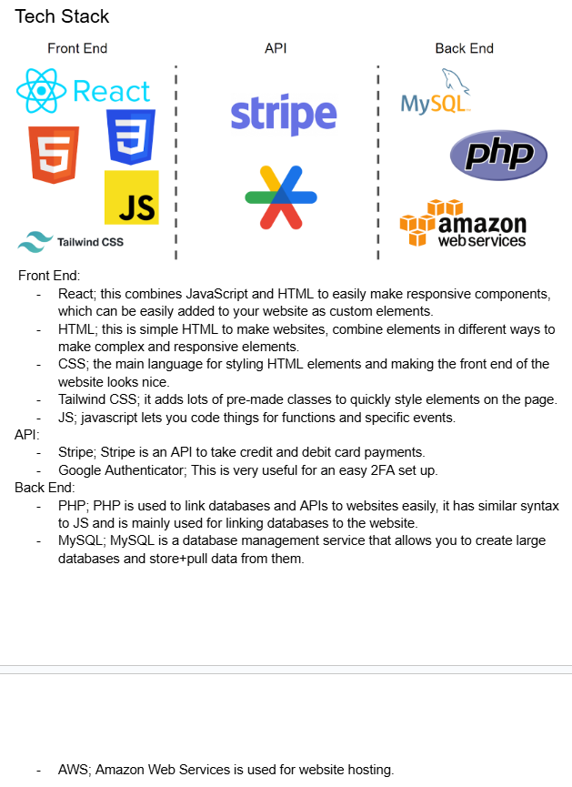

**Sources to use:**

**Examiners report:**

**Key Performance Indicators (KPI’s)**

**Main tip:** Key Performance Indicators (KPIs) are measurable values that assess how effectively a project or system meets its objectives. They should be based on SMART goals (Specific, Measurable, Achievable, Relevant, and Time-bound) to ensure that evaluations are objective and fair.

KPIs must cover non-functional requirements, ensuring that all critical aspects of performance are met.

A key idea of KPIs is that they must be quantitative instead of qualitative, allowing for clear measurement and comparison.

**Examples:**

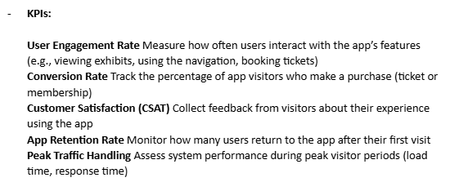

**Sources to use:**

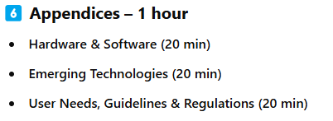

**Emerging technologies**

**Main tip:** To show which new technologies can be included

**Examples:**

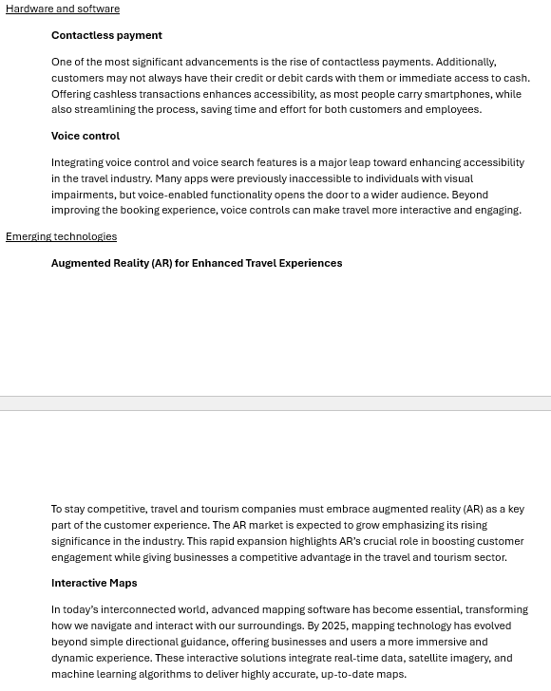

**Sources to use:**

**Examiners report:**

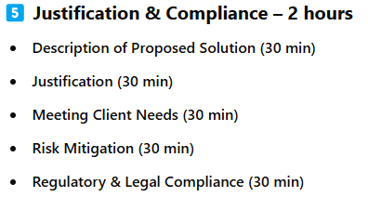

**Legal Regulatory and Ethical Considerations**

**Main tip:** GDPR, COPPA, COOKIE LAW

EQUALITY ACT, ACCESSIBILITY

ETHICAL USE OF IMAGES+TEXT

**Examples:** Principles

Lawfulness Data must be acted with and gathered lawfully, and used in ways

the user can expect.

Purpose Limitation Data purpose must be made clear and only collected if

user agrees.

Data minimisation Data must be necessary for the purpose you gathered it.

Accuracy Inaccurate data is never kept, and data is updated.

Storage limitation Any unnecessary data is deleted.

Integrity & confidentiality Responsiblility for ensuring data security is made

clear. Actions are taken to enure data securtity

Accountability Compliance must be demonstrable.

**Sources to use:**

**Examiners report:**

**Proposed Solution Description**

**Main tip:** For this task you will be summarizing what you have done above and explain the main benefits it will have for the client.

**Examples:**

**Sources to use:**

**Examiners report:**

**Rational Proposal**

**Main tip:**

**Examples:**

**Sources to use:**

**Examiners report:**

***Examiners Report:***

